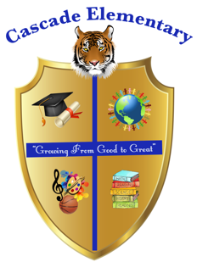

Cascade Elementary Website
Weekly Grade Level News Blast

Week of: Monday, April 13, 2020

Grade Level: 5

Standards of the Week:
ELA: ELAGSE5RI9: Integrate information from several texts on the same topic in order to write
or speak about the subject knowledgeably.
ELAGSE5RL6: Describe how a narrator's or speaker's point of view influences how events
are described.

Math: MGSE.5.G.1 & MGSE.5.G.2 Graph points on the coordinate plane to solve real-world and mathematical problems.
MGSE.5.OA.3 Analyze patterns and relationships.

Social Studies: SS5H6 Describe the importance of key people, events, and developments between 1950-1975.
SS5G1 Locate important places in the United States.
- Locate important man made places; include Montgomery, AL

Science: S5L1. Obtain, evaluate, and communicate information to group organisms using scientific
classification procedures.

Additional Information for Parents and Students:
WELCOME BACK FROM SPRING BREAK! We hope you relaxed and enjoyed your time!

If students have not logged in to the Cascade 5 Weatherwise Google classroom please have them do so. All work is posted daily!
If students do not have the class listed in their Google Classroom they can add it by using the 5th grade code: 2azkss7

We will continue our virtual classroom meetings every day at 11am. Please have students log in to learn straight from their teacher!

If you need to get in contact with your student’s homeroom teacher please feel free to email:
Ms. O’Malley – jessica.omalley@atlanta.k12.ga.us
Ms. Adamu – ummulkhairi.adamu@atlanta.k12.ga.us
Mr. Spraggins – darrell.spraggins@atlanta.k12.ga.us

